**Project Title:**

# Power BI Inflation Analysis:

# Journeying Through Global Economic Terrain

**Software: Power BI**

**Submitted by**

**Mr. Dikshant Deelip Godghate**

**Under The Guidance of**

**Mr. Moses**

# D. Y Patil Institute of Masters of Computers Application and Management, Akurdi, Pune-4110

**INDEX**

1. **Executive Summary** 1
2. **Introduction** 1
3. **Methodology** 2
4. **Dashboard Overview** 3
5. **Dashboard Output** 4
6. **Findings and Insights** 5
7. **Strategic Recommendations** 5
8. **Conclusion** 6
9. **Appendices** 6

## Executive Summary

Inflation is a critical economic indicator that profoundly impacts businesses, consumers, and policymakers. This report presents a comprehensive analysis of inflation trends using Power BI to empower multinational corporations with actionable insights. By analyzing global inflation data, this project supports the development of informed pricing strategies, risk mitigation plans, and investment decisions.  
  
The report highlights the use of dynamic visualizations to explore inflation across multiple dimensions, including geographic, sectoral, and demographic variables. Stakeholders can leverage these insights for effective decision-making tailored to specific market conditions.

## Introduction

Inflation, as a measure of the average price change over time, is pivotal in assessing economic health and monetary policy effectiveness. This report explores the analytical capabilities of Power BI in examining global inflation trends and patterns.  
  
The objective of the project is to:

* Provide a detailed analysis across regions, sectors, and consumer demographics.
* Deliver strategic recommendations through interactive dashboards and actionable insights.

## Methodology

The analysis involves the following steps:

**1. Data Collection and Preparation:**  
 - Acquired inflation data from reliable global sources.  
 - Cleaned and transformed data to ensure accuracy and compatibility for analysis.

**2. Data Modeling:**  
 - Established relationships between data dimensions, including geography, sectors, and consumer groups.

**3. Visualization Development:**  
 - Utilized Power BI to create interactive and user-friendly dashboards.

**4. Dynamic Filtering:**  
 - Incorporated selection tools to allow users to explore data dynamically based on specific countries or regions.

## Dashboard Overview

The interactive Power BI dashboard, titled **“Power Inflation Analytics: Journeying Through Global Economic Turmoil,”** features the following visualizations:  
  
**1. Inflation Rate:**

* Displays the overall inflation rate as a key metric for gauging economic health.

**2. Inflation Expectations:**

* Projects trends based on public and expert predictions, emphasizing potential future inflationary pressures.

**3. Inflation Rate by Country:**

* A bar chart comparing inflation rates across various countries, enabling a cross-country analysis of economic conditions.

**4. Inflation Rate by Region:**

* A bar chart offering insights into inflation trends across different geographic regions, identifying regional disparities.

**6. Inflation Rate by Sector:**

* A sectoral analysis highlighting industries most affected by inflationary pressures, providing insights for sector-specific strategies.

## Dashboard Output

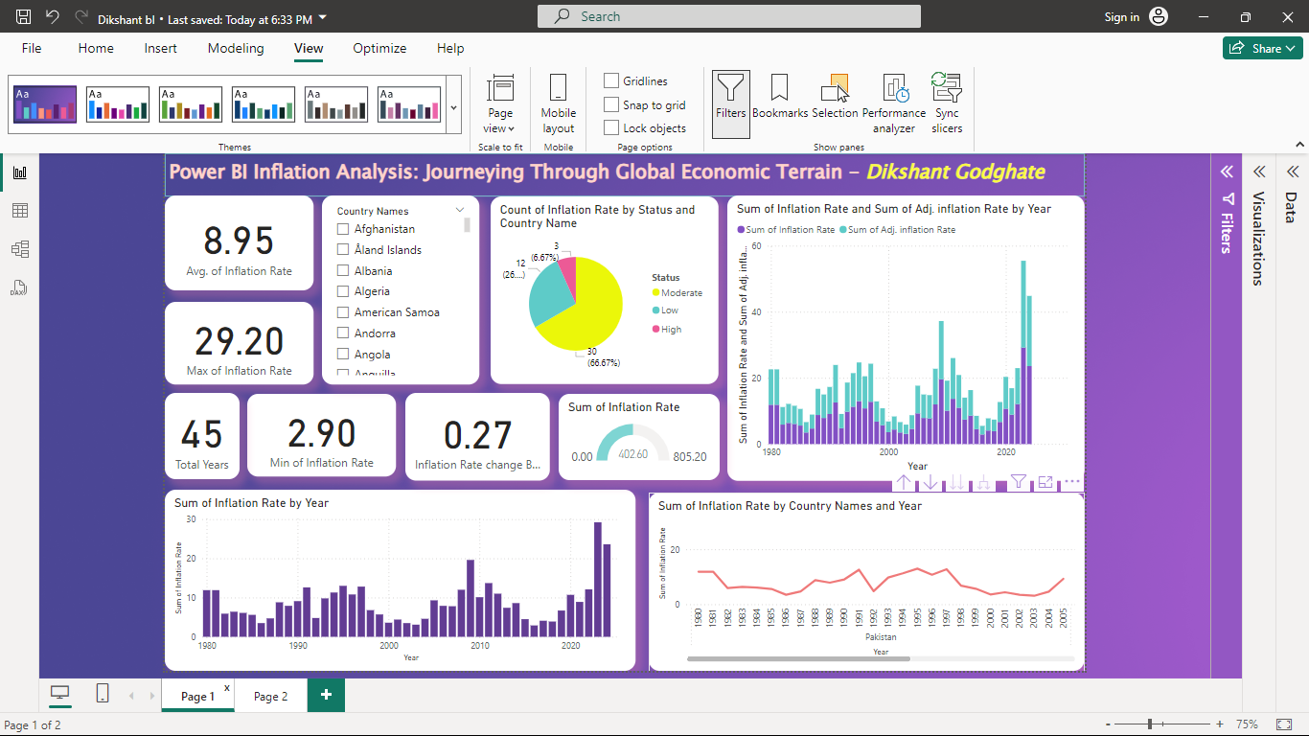

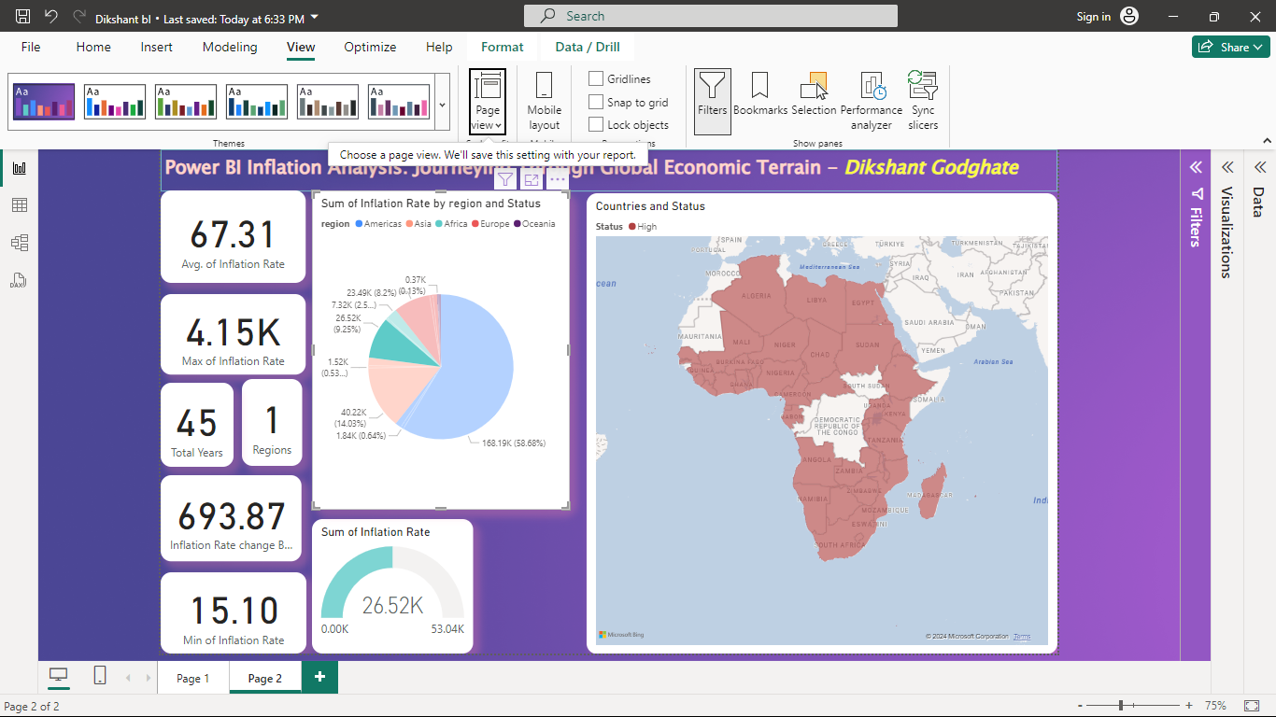

## Findings and Insights

* **Geographic Trends:** Regional and country-specific variations reveal significant economic disparities.
* **Sectoral Dynamics:** Inflation impacts certain sectors more profoundly, reflecting supply chain vulnerabilities.
* **Demographic Analysis:** Consumer groups and product types experience differing inflationary pressures, highlighting areas requiring targeted interventions.

## Strategic Recommendations

Based on the analysis, the following recommendations are proposed:

1. Pricing Strategies: Adjust pricing dynamically in regions or sectors experiencing higher inflation to maintain profitability.

2. Risk Mitigation: Diversify supply chains to minimize disruptions contributing to inflationary pressures.

3. Investment Decisions: Focus on sectors and regions with stable or decreasing inflation trends for sustainable growth.

## Conclusion

This analysis underscores the importance of leveraging advanced business intelligence tools like Power BI to understand complex economic phenomena such as inflation. The insights derived from this report empower decision-makers to navigate the challenges of global economic variability effectively.

## Appendices

Appendix A: Data sources and references.

* https://www.kaggle.com/datasets/sazidthe1/global-inflation-data

Appendix B: Github Link

* https://github.com/DIKSHANT071998/Power-BI

Appendix C: Drive Video Link

* https://drive.google.com/file/d/1Ix5RNw3OoMcCRW-jw9WlQJFhfrm1M2b_/view?usp=sharing